BENCHMARK ENGLISH GRADE 1
ANSWER KEY
UNIT #1
Exercise
Reading Skills
Great! Let's solve the exercises based on the image you sent.
A. Reading Comprehension: Colour the correct words in the given sentences.
- Abida is six years old.
- Abida lives in Karachi.
- Abida's favorite color is green.
- Abida likes to eat mangoes.
- Abida wants to be a doctor.
B. Read the given letters and say their sounds. Also circle the capital letters.
- Aa (Capital A, sound: /æ/ or /eɪ/)
- Dd (Capital D, sound: /d/)
- Ee (Capital E, sound: /ɛ/ or /iː/)
- Gg (Capital G, sound: /ɡ/)
- li (Capital I, lowercase i, sounds: /l/, /ɪ/)
- LI (Capital L, Capital I, sounds: /l/, /ɪ/)
- Nn (Capital N, lowercase n, sounds: /n/)
- Pp (Capital P, lowercase p, sounds: /p/)
- Ss (Capital S, lowercase s, sounds: /s/)
- Uu (Capital U, lowercase u, sounds: /ʌ/ or /juː/)
- Ww (Capital W, lowercase w, sounds: /w/)
- Zz (Capital Z, lowercase z, sounds: /z/)
C. Read the given sight words. Remember sight words are the words that we memorize by sight.
- eye
- you
- see
- for
- one
PHONICS
A. Repeat the given words after your teacher. Focus on the sounds of the initial and final consonants.
This exercise is primarily about pronunciation and phonemic awareness. Here's a breakdown of the initial and final consonant sounds for each word:
- mat:
  - Initial consonant: /m/
  - Final consonant: /t/
- jug:
  - Initial consonant: /j/
  - Final consonant: /g/
- fin:
  - Initial consonant: /f/
  - Final consonant: /n/
- bus:
  - Initial consonant: /b/
  - Final consonant: /s/
- bat:
  - Initial consonant: /b/
  - Final consonant: /t/
- run:
  - Initial consonant: /r/
  - Final consonant: /n/
- push:
  - Initial consonant: /p/
  - Final consonant: /h/ (the "sh" sound)
- van:
  - Initial consonant: /v/
  - Final consonant: /n/
- duck:
  - Initial consonant: /d/
  - Final consonant: /k/
- zip:
  - Initial consonant: /z/
  - Final consonant: /p/
- leg:
  - Initial consonant: /l/
  - Final consonant: /g/
- yarn:
  - Initial consonant: /y/
  - Final consonant: /n/
VOCABULARY & GRAMMAR
A. Name the pictures, write the beginning sound/letter, and cross out the odd one (not a fruit).
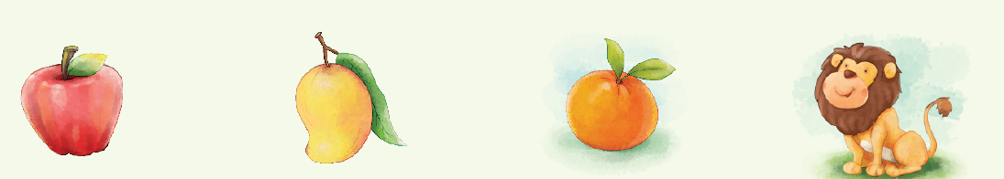
(i)
- Picture 1: Apple
  - Beginning sound/letter: A
- Picture 2: Mango
  - Beginning sound/letter: M
- Picture 3: Orange
  - Beginning sound/letter: O
- Picture 4: Lion
  - Beginning sound/letter: L
Cross out the odd one: The Lion is not a fruit, so it should be crossed out.
A. Categorize the above-mentioned words here:
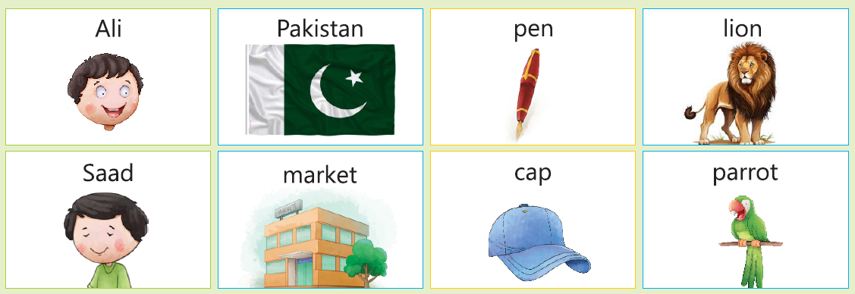
- Persons:
  - Ali
  - Saad
- Places:
  - Pakistan
  - market
- Things:
  - pen
  - cap
- Animals:
  - lion
  - parrot
B. Identify the pictures and write their names in the given spaces.
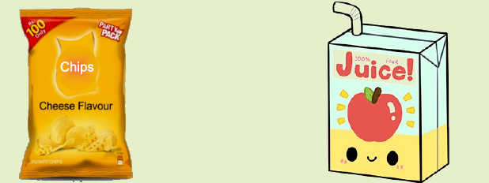
- Picture 1: Chips
- Picture 2: Juice
C. You can see a tree, a slide, a boy, a girl, and a ball, etc. in the picture. Change these into plurals.
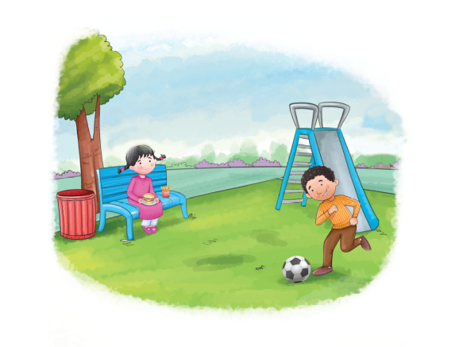
- tree: trees
- girl: girls
- slide: slides
- bench: benches (Note: This is an exception; it adds "-es" because it ends in "ch")
- boy: boys
- bin: bins
- football: footballs
D. Write the plurals of the words by adding 's'.
- bag: bags
- pan: pans
- lion: lions
- cat: cats
- book: books
- fork: forks
E. Write the singulars of the words by removing 's'.
- blocks: block
- pencils: pencil
- bags: bag
- bats: bat
- cars: car
- tables: table
WRITING SKILLS
A. Trace and write the given sentence:
- I love my parents.
B. With the help of the given 'mind map', introduce yourself.
Template (with example answers):
- Name: Aiza
- Age: 7
- Your city: Lahore
- Grade you study in: Grade 2
- Family members: Mom, Dad, and a younger brother
- Your unique quality: I'm good at drawing
- Favourite food items: Pizza, ice cream, and mangoes
- Favourite game: Soccer

UNIT #2
Exercise
Reading Skills
Okay, I have the exercises for the "Love for Pakistan" poem. Let's create the answer key.
A. Answer the following questions in one word.
- What is the name of your country?
  - Pakistan
- Are you proud of your country?
  - Yes
- What does your motherland give you?
  - (Based on the poem) Love / Freedom / Beauty / Happiness / etc. (Accept any answer that fits the context of the poem's themes)
- Should we keep our motherland clean?
  - Yes
B. Read the poem "Love for Pakistan" and underline the rhyming words.
- dear and cheer
- free and thee
- blue and too
- hand and understand
- clear and dear
- true and you
C. Use the opposite words in your sentences.
- old:
  - Opposite: new
  - Sentence: "My grandfather's car is old, but my dad's car is new."
- slow:
  - Opposite: fast
  - Sentence: "The turtle is very slow, while the rabbit is very fast."
- hard:
  - Opposite: easy / soft
  - Sentence: "The math problem was hard, but the spelling test was easy."
  - Sentence: "The rock is hard, but the pillow is soft."
- small:
  - Opposite: big / large
  - Sentence: "My cat is small, but the dog is big."
  - Sentence: "This room is small, but the hall is large."
PHONICS
A: Name three words with short vowel sound.
Based on the provided list, here are three words with short vowel sounds:
- cab (short "a" sound)
- bed (short "e" sound)
- gem (short "e" sound)
Vocabulary & Grammar
A. Look at each picture. Write the emotions every face is expressing. Take help from the word bank.
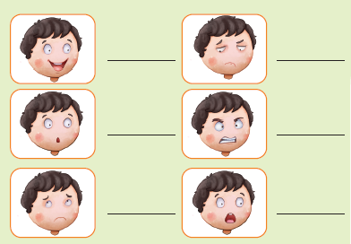
- Top Left: Happy
- Top Right: Worried
- Middle Left: Surprised
- Middle Right: Angry
- Bottom Left: Sad
- Bottom Right: Scared
B. Match the opposite words.
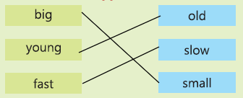
Writing Skills
A. Rewrite the sentences by using correct capitalization.
- we are going to school.
  - We are going to school.
- are you going to the park?
  - Are you going to the park?
- they are in the library.
  - They are in the library.
- isha has a bucket.
  - Isha has a bucket.
- rida is sleeping.
  - Rida is sleeping.
B. Listen to the story of the thirsty crow from your teacher. Answer the given questions.
Questions:
- Where was the crow flying when he got thirsty?
  - The crow was flying over a village.
- What lesson can we learn from the crow's actions?
  - We can learn that with cleverness and persistence, we can solve problems.

UNIT #3
Exercise
Reading Skills
A. Write (T) for the correct sentences and (F) for the false sentences.
- Respect means to shout at others.
  - (F) (False)
- For Saba, respect is to help others.
  - (T) (True)
- For Naveen, respect is to share things.
  - (F) (False) (Naveen said to use kind and polite words)
B. Read these sight words:
- after
- give
- let
- some
- again
- once
- may
- over
- thank

C. Circle the sight words in the chapter 'Let Us Learn Respect.'
In a classroom filled with
nice students, Miss Zara
began a special lesson about respect. "Today, my
dear students", Miss Zara said with a warm smile, "we
shall learn about the many ways we can show respect
to others." She asked the students, "What does
respect mean to you?"
Ali said, 'Respect means being nice to
others."
"Exactly", said Miss Zara. "Let us explore some ways we can show respect."
Naveen: We can use kind and polite
words like 'please', 'thank you'
and 'excuse me.'
D. With the help of your teacher, read the signs and match them to the instructions.
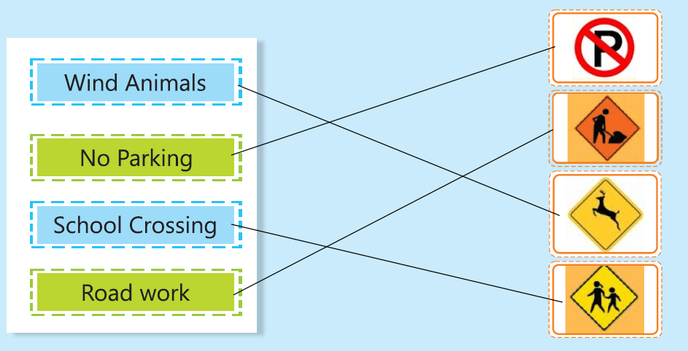
Phonics
A. Say three more words with short vowel sounds.
- map (short "a" sound)
- hen (short "e" sound)
- fox (short "o" sound)
Vocabulary & Grammar
A. Name the letters from 'a' to 'z'. These are in alphabetical order. Look at the first letter of these words and arrange them in alphabetical order (a, b, c).
- Letters 'a' to 'z': a, b, c, d, e, f, g, h, i, j, k, l, m, n, o, p, q, r, s, t, u, v, w, x, y, z
- Alphabetical order of the words:
  - bat (b)
  - cat (c)
  - fat (f)
  - hat (h)
  - mat (m)
  - rat (r)
B. Write the rhyming words.
- fall: tall
- big: pig
- run: sun
- pod: nod
- car: far
- bee: tree

B. Write the feminine gender of these words. Choose from the words given in the box.
(Words in the box: sister, queen, hen, mother, girl, lioness)
Question (Masculine) | Answer (Feminine)
brother | sister
father | mother
king | queen
boy | girl
cock | hen
lion | lioness

Okay, let's add the punctuation to these sentences.
C. Put a full stop (.) or a question mark (?) where necessary, in each sentence.
- My name is Irfan.
- What is your name?
- Can you see the bird?
- I see the train.
- I am fine.
- Where are you going?
D. Read the following sentences and put a comma (,) where it is necessary.
- There are pencils, erasers and scissors on each table.
- Give me glue, paper and markers.
- Put the utensils, the dishes and the glasses on the table.
- Ali likes to play cricket, football and hockey.
- I have an orange, a sandwich, chips and juice for my lunch.
WRITING SKILLS
B. Write a simple sentence about each picture.
- This is a ball. (Provided as an example)

- This is a moon.
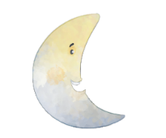
- This is a cup.


UNIT #4
Exercise
A. Answer the following questions.
i. What type of ride did Rohan and Ali enjoy?
They enjoyed a magical train ride.
ii. Were Rohan and Ali happy to meet new friends?
Yes, they were happy to meet new friends.
iii. What did the train windows show?
The train windows showed tall mountains, flowing rivers, and a forest full of chirping birds.
iv. Do you like to have friendship with different people?
Yes, I like making new friends.
B. Look at the pictures and fill in the missing consonant blend to complete the words.
- Flag (Missing blend: fl)
- Green (Missing blend: gr)
- Crow (Missing blend: cr)
C. Read the sight words given below and encircle the sight words in the chapter "The Magical Train Ride."
- them
- were
- when
- know
- just
- from
Once upon a time, in a land full of wonders, two friends, Rohan and Ali went on a magical train ride. The train had comfortable seats, colourful buttons, lights and sounds to engage the passengers. The decoration was cozy. They met Shilpa from India Salman from Saudi Arabia and Ted from Itlay.They all became friends. During their journey, they saw tall mountains, flowing rivers, and a forest full of chirping birds. At a station, a kind conductor greeted them. "Ticket, please!" he said with a smile. The children showed their tickets. " Now just stop, have a look at the magical castles!", announced the conductor. Upon reaching the castle, they enjoyed delicious treats like chocolates, cotton candies, cakes, fruits and milk. They explored its secret passages and met a friendly dragon. The dragon offered them a ride on his back, flying over the castle. As the sun set, they returned to the train, tired but happy. The children know that even though they were different, they could still be friends and have fun together." What an adventure!" Rohan said. Ali nodded, " Best travel ever!"
D. Read the poem and answer the given questions. Make pairs of the rhyming words.
- Colours!
Red, blue, yellow, and green Four bright colours to be seen. Red is the colour of the rose, that I smell with my nose. Blue is the colour of the sky, with fluffy clouds, way up high. Yellow and green can be found, on grass and flowers all around.
Rebecca T. Besser
- Rhyming pairs:
  - green - seen
  - rose - nose
  - sky - high
  - found - around
Questions:
i. 'Green' rhymes with the word seen.
ii. Rose rhymes with the word 'note'. (This should be nose, I believe it's a typo in the question)
PHONICS
B. Fill in the missing letters to complete the one-and-two-syllable words, then read these words to your class.
- sil_nt: silent
- hell_: hello
- d_sk: desk
- mon_y: money
- t_ger: tiger
- carr_t: carrot
- f_sh: fish
- cl_ss: class
- h_ve: have
VOCABULARY & GRAMMAR
A. Read the given sentences.
- My name is Ahmar. I am a boy.
- This is Saba. She is a student.
- That is Habib. He is a driver.
- This is a dog. It has a long tail.
- These are farmers. They work in the fields.
- You are Farhat. You are my friend.
D. Fill in the blanks by writing the correct pronouns for the underlined nouns.
i. My father is a doctor. He treats ill people.
ii. Sara and Amna are friends. They play and stay together.
iii. Rida is my younger sister. She is a naughty girl.
iv. This is my house. It is big and airy.
E. Read the sentences.
- Sana reads a book.
- Ali works.
- Yousaf offers his prayers daily.
These sentences show habitual actions or things people do every day.
What are five things you do every day?
(Example given: sleep, eat, drink water, offer prayers, play with my siblings)
- Brush my teeth.
- Go to school.
- Do my homework.
- Watch TV.
- Help my mom.

D. Write the salient features of 'the magical train' in the given 'bubble map'.
Feature of the Magical Train
Comfortable seats
Colorful buttons
Lights and sounds
Magical castles (destination)
Tall mountains (view from windows)
Flowing rivers (view from windows)

UNIT #5
Exercise
A. Reading Comprehension
- i. How are the students dressed up?
  - Answer: The students are dressed up in different colors and in the traditional clothing of different provinces of Pakistan.
- ii. Which province is Hashir representing?
  - Answer: Hashir is representing Balochistan.
- iii. What is Zain wearing?
  - Answer: Zain is wearing Ajrak and Sindhi Topi.
B. Read the given sight words.
- This section is for reading practice. The words are:
  - round
  - every
  - just
  - after
C. Name the given pictures. Take help from the given words.
- Here are the answers, matching the pictures with the provided words:
  - tap

  - cup

  - wet

  - hen
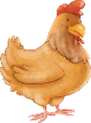
  - pot
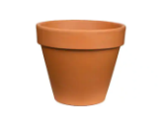
  - bug
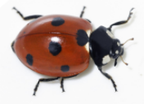
  - map
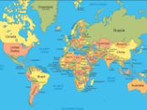
  - bed
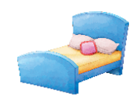
D. Read the followings and write three sentences in your notebook.
Sentence 1:
- Words: They + went + to + the park.
- Sentence: They went to the park.
Sentence 2:
- Words: We + are + Muslims.
- Sentence: We are Muslims.
Sentence 3:
- Words: I + like + to + eat + biryani.
- Sentence: I like to eat biryani.
Communication Skills
C. Read the given words and make sentences using these words.
Answers:
- "I water the plant twice a day."
- "The boy jumps."
PHONICS
A. Give two examples of soft and hard 'th' sounds.
- Soft "th" examples:
  - thin
  - bath
- Hard "th" examples:
  - this
  - that
VOCABULARY & GRAMMAR
A. Fill in the spaces with 'What, Who, When and Why.'
- Who is she? She is a doctor.
- When is your birthday? It is in June.
- When is Eid ul-Fitr? It is on 13th July.
- Where is she? She is at school.
- Who is she? She is a poetess.
WRITING SKILLS
A. Write a few lines about your favourite Pakistani culture.
Balochi Culture
Balochi culture is very interesting.
The Balochi people wear beautiful turbans.
Their clothing is full of facts about their history.
The music and dances are very enjoyable.
I like the Balochi dress.
UNIT #6
EXERCISE
Reading Skills
A. Answer the following questions.
- Do you take a shower every day?
  - Answer: Yes, I take a shower every day.
- What do you use to wash your hair?
  - Answer: I use shampoo to wash my hair.
- How many times do you brush your teeth in a day?
  - Answer: I brush my teeth twice a day.
- What do you use to keep your teeth clean? Tooth paste or tooth powder?
  - Answer: I use toothpaste to keep my teeth clean.
- Do you like personal cleanliness? Why?
  - Answer: Yes, I like personal cleanliness because it keeps me healthy and clean.
B. Use the following words in your sentences.
- comb: I use a comb to brush my hair.
- care: I take care of my body by keeping it clean.
- healthy: Eating fruits and vegetables keeps me healthy.
- dust: I wipe the dust off my toys.
- cleanliness: Cleanliness is important for good health.
C. Write 'T' for the correct sentences and 'F' for the false.
- We do not need to brush our teeth daily.
  - Answer: F (False)
- Keeping ourselves clean is a good habit.
  - Answer: T (True)
- We must comb our hair daily.
  - Answer: T (True)
- We use shampoo to wash our hair.
  - Answer: T (True)
- We can stay healthy by keeping ourselves clean.
  - Answer: T (True)
D. Recite the given poem with actions and answer the questions in one word. Show awareness of rhythmic structure of the poem by clapping. Learn this poem and read it to your class orally.
Questions and Answers (One Word):
- Is the sea deep and wide?
  - Answer: Yes
- Do the seagulls soar up high?
  - Answer: Yes
- How do children enjoy the sea?
  - Answer: Play
- Pair up the rhyming words.
  - Answer:
    - wide - slide
    - shore - roar
    - high - by
    - sun - fun
VOCABULARY & GRAMMAR
A. Put 'a' or 'an' where necessary. Follow the examples.
- ___ egg
  - an egg
- ___ apple
  - an apple
- ___ bicycle
  - a bicycle
- ___ sparrow
  - a sparrow
- ___ cat
  - a cat
- ___ inkpot
  - an inkpot
- ___ orange
  - an orange
- ___ cake
  - a cake
- ___ umbrella
  - an umbrella
- ___ box
  - a box
B. Say the names of months of the year in the correct order and answer the given questions.
- How many days are there in a week?
  - 7
- What is your birth month?
  - (This will vary depending on the student's birth month. Example) August
- How many months are there in a year?
  - 12
C. Complete the words.
- Ma_ch
  - March
- Dec_mber
  - December
- J_ne
  - June
Writing Skills
A. Look at the given picture. Write three sentences in your notebook about how can you keep a park clean. You can use the words: dustbin, papers and wrappers.
- Put papers and wrappers in the dustbin.
- Don't throw papers on the ground.
- Keep the dustbin clean.
B. Read the given text. Write a simple short opening sentence which highlights the topic sentence.
- Opening sentence: Cleanliness is very important for our health.
C. These children have health and hygiene problems. Suggest them a way to be healthy.
- Ali eats too many sweets. He has cavity in his teeth.
  - Suggestion: Ali should eat less sweets and brush his teeth twice a day.
- Asad is skinny as he does not eat fruits and meat.
  - Suggestion: Asad should eat fruits and meat to become strong.
- Adeel doesn't smell nice as he does not keep his clothes clean.
  - Suggestion: Adeel should wash his clothes every day.
UNIT #7
EXERCISE
READING SKILLS
A. Fill in the blanks with the correct option.
- Ali was very excited because Eid was just around the corner.
- Ali's mother was busy preparing delicious treats and cookies.
- On the morning of Eid, Ali and his family went to the mosque to offer their prayer.
- Eid is a time for sharing, caring and celebration.
- Ali received Eidi from his relatives.
PHONICS
A. Name two more words with a long 'e' sound.
- feet
- tree
VOCABULARY & GRAMMAR
B. Underline the adjectives in the given sentences.
- The girl has a sweet voice.
- They went to a big park.
- She is a tall girl.
D. Read the given sentences and tick the pictures according to adjectives.
- It is a small cat.
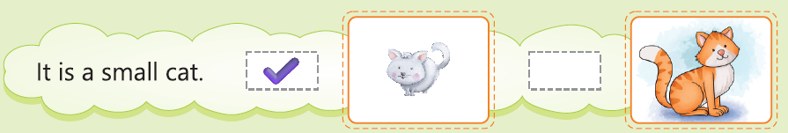
- It is a big house.
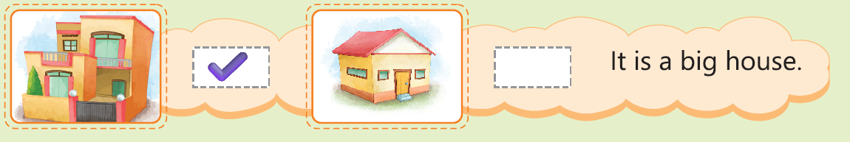
F. Look at the given pictures and write the adjectives that show their colour.
- Red apple
- Blue shirt
- Yellow mango
- Green jacket
WRITING SKILLS
A. Write four sentences in your notebook about your favourite flower. Use the given word bank.
- The rose is a beautiful flower.
- I like the rose very much.
- The rose has a nice smell.
- The color of the rose can be red or pink.
UNIT #8
Exercise
Reading Skills
A. Complete the sentences.
- Ali was from Islamabad.
- Yasir was from Kasur.
- Ali was brilliant.
- Ali and Yasir became friends.
B. Use these words in your sentences.
- nice: Ali is a nice boy.
- meet: I want to meet my friend.
- read: I can read a book.
- best: My mother is my best friend.
- brilliant: Ali is a brilliant reader.
PHONICS
A. Give three examples of long 'i' sound.
- die
- fries
- kite
VOCABULARY & GRAMMAR
A. Look at the picture and complete the sentences.
- Amir reads a newspaper.
- Zafar rides a bicycle.
- Amina plays with a ball.
- Waqas shares his lunch with a friend.
B. Look at the pictures and construct simple sentences using nouns and verbs.
- Ali runs.
- Ali reads.
- Ali swims.
WRITING SKILLS
A. Write three sentences about 'My best friend' using the given word bank.
- My best friend is caring and loving.
- She reads in my class and has good habits.
- We are the same age.
UNIT #9
EXERCISE
READING SKILLS
A. Tick (✓) the correct option
- What do trees give us?
(b) oxygen ✓
- What is the rhyming word for ‘berries’ mentioned in the poem?
(b) cherries ✓
- What do trees need?
(b) water and soil ✓
PHONICS
A. Name three more words with 'oa' sound.
- Boat
- Goat
- Road
VOCABULARY & GRAMMAR
A. Put suitable prepositions in the following sentences (in, on, near):
- Rehman is sitting on his chair.
- The teacher wrote on the blackboard.
- Ayesha ran quickly near the hill.
- There is a mouse in my kitchen.
- Ali is standing near the wall.
WRITING SKILLS
A. Name five things we can get from trees.
- We get fruits from trees.
- We get wood from trees.
- Trees give us oxygen.
- Trees give us shade.
- We get paper from trees.
UNIT #10
EXERCISE
Reading Skills
A. Tick (✔) the correct option.
- Sana and Arham were making:
  - (a) an invitation
- The first step to make an invitation card is:
  - (b) to fold a piece of paper in half
- Who wrote greetings on the invitation card?
  - (b) Arham
C. Rearrange and spell the jumbled words.
- ainr - rain
- nus - sun
- lcoud - cloud
- ezbra - zebra
- rneeg - green
- der - red
D. Rearrange the given words to make sentences.
- Sunday It is
  - It is Sunday.
- a scooter They have
  - They have a scooter.
- a car have We
  - We have a car.
- It Friday is
  - It is Friday.
PHONICS
A. Name three words with a long 'u' sound.
- use
- tune
- flute
VOCABULARY & GRAMMAR
A. Replace the underlined words with a pronoun from the word box. (He, She, It, We)
- My brother is tall.
  - He is tall.
- He and I share an apartment.
  - We share an apartment.
- My mother is a doctor.
  - She is a doctor.
- The giraffe is tall.
  - It is tall.
A. Replace the underlined words with a pronoun from the word box. (He, She, It, We)
- My brother is tall.
  - He is tall.
- He and I share an apartment.
  - We share an apartment.
- My mother is a doctor.
  - She is a doctor.
- The giraffe is tall.
  - It is tall.
WRITING SKILLS
A. Look at the given food items. Write if they are healthy for us or not.
- Biscuits: Not healthy
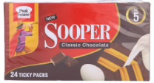
- Chips: Not healthy

- Juice: Healthy

UNIT #11
EXERCISE
A. Tick (✔) the correct option.
- Ali lived in:
  - (a) a village
- Ali needed to learn:
  - (a) self discipline
- Ali's father gave him:
  - (a) a plant
- Ali watered the plant:
  - (a) daily
B. Answer these questions.
- Why is it important not to waste time?
  - Time is special. If we waste time, we cannot do important things.
- Can you think of some common activities that may waste time? How can we avoid these activities?
  - Playing too many games.
  - Watching too much TV.
  - We can stop playing and watching TV after a little while.
- What are some ways you can manage your time better at home and in school?
  - Do homework first.
  - Play after homework.
  - Listen to the teacher at school.
C. Summer Vacation Mind Map:
Summer Vacation
Visiting Grandparents
Playing Cricket
Swimming
Eating Mangoes
Going to Park
Reading Stories

E. Look at the given titles. Tick the book with the title 'Little Red Riding Hood'.
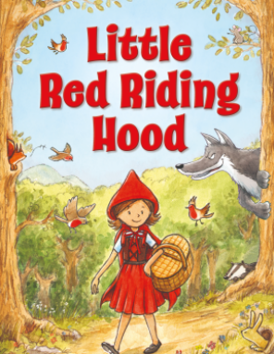
PHONICS
A. Think about more examples of the words ending with "ff", "ll", "ss" and "zz".
- ff:
  - stiff
  - puff
  - muff
- ll:
  - bell
  - shell
  - doll
- ss:
  - dress
  - glass
  - kiss
- zz:
  - fuzz
  - whizz
  - fizz
VOCABULARY & GRAMMAR
A. Use a picture dictionary to find the spellings of the names of these pictures. Write them here and read them aloud.
- Book
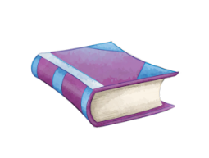
- Train
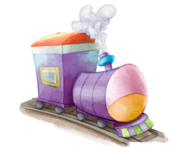
- Table
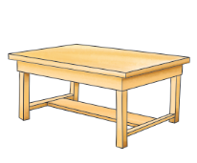
B. Put articles 'a' or 'an' and rewrite the sentences.
- I have a new school bag.
- They have a car.
- Umar is eating an orange.
D. Write 'R' for request and 'C' for command in the given blanks.
- Please help me. R
- Could you please share your pencil with me? R
- Open your books. C
- Sit down. C
WRITING SKILLS
A. Write your name and phone number.
- Name: (Student's name)
- Phone Number: (Student's phone number or a made-up number if they don't have one)
B. You have read the story about Ali. Change the concluding sentence of the story.
- Concluding Sentence: He learnt that by utilizing his time properly, he could achieve more.
CHANGE:
- Ali was happy because he learned to use his time well.

